Name _______________________________________________
Rubric for Comic Strip Tutorial

 |  | Example below
Tutorial is well done and all instructions followed.. Applied Adjustment curves for contrast, grain filter and Color Halftone filter, blending mode and inside stroke around border | 10
Font is Comic Font downloaded and Current Date put in square as shown. Text is appropriate and designed well (Example J in January) and square as shown…. (extra up to +5 for adding appropriate thought or speech bubble)  Students name is put in lower left corner of comic as shown. | 10 | 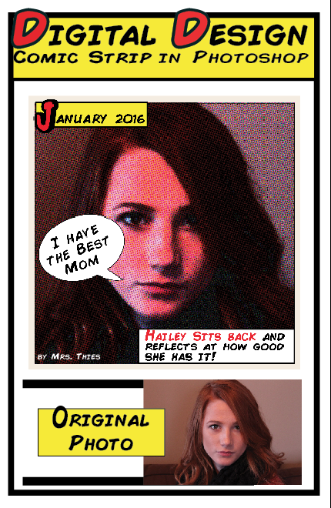
INDESIGN Poster part is complete  Correct Size: (1/2 sheet of paper) 5.5" Wide by 8.5" Height, .3" Margins | 5
Original Picture smaller than Comic one and placed on page | 5
Title: Digital Design Comic Strip in Photoshop Comic Font and something special done to it…see example (Character panel used) | 5
Design Elements and border:  Lines, shapes, color, contrast etc.  Overall Look, Layout, content and cutout and put on construction paper See Example on board…  Print>Print> Setup> Page Position>Centered  Marks and Bleeds> Turn on Crop Marks  Paperclip Rubric and Turn in | 10
TOTAL | 45

Name _______________________________________________
Rubric for Comic Strip Tutorial

 |  | Example below
Tutorial is well done and all instructions followed.. Applied Adjustment curves for contrast, grain filter and Color Halftone filter, blending mode and inside stroke around border | 10
Font is Comic Font downloaded and Current Date put in square as shown. Text is appropriate and designed well (Example J in January) and square as shown…. (extra up to +5 for adding appropriate thought or speech bubble)  Students name is put in lower left corner of comic as shown. | 10
INDESIGN Poster part is complete  Correct Size: (1/2 sheet of paper) 5.5" Wide by 8.5" Height, .3" Margins | 5
Original Picture smaller than Comic one and placed on page | 5
Title: Digital Design Comic Strip in Photoshop Comic Font and something special done to it…see example (Character panel used) | 5
Design Elements and border:  Lines, shapes, color, contrast etc.  Overall Look, Layout, content and cutout and put on construction paper See Example on board…  Paperclip Rubric and Turn in | 10
TOTAL | 45

