Name _________________________________________________
Illustrator Typography Chapter 2 Assignment 1
2 panels that matter…character and paragraph

New Document for print (Change to inches) Last Name First Initial Typographylesson1
Type a 2-4 Word Saying in Illustrator (Duplicate it 4 more times…total of 5) See site for example

Make sure this takes up whole page (you may separate with lines or boxes if you wish). Use the character and Paragraph panel only to make adjustments (you may adjust weight of stroke).

Top two saying must use Sans Serif font, Second 2 must use Serif font, last one you can use any combination. (in box beside tell me what you did)
Set the page up evenly and attractively name in bottom right and print to BW printer.

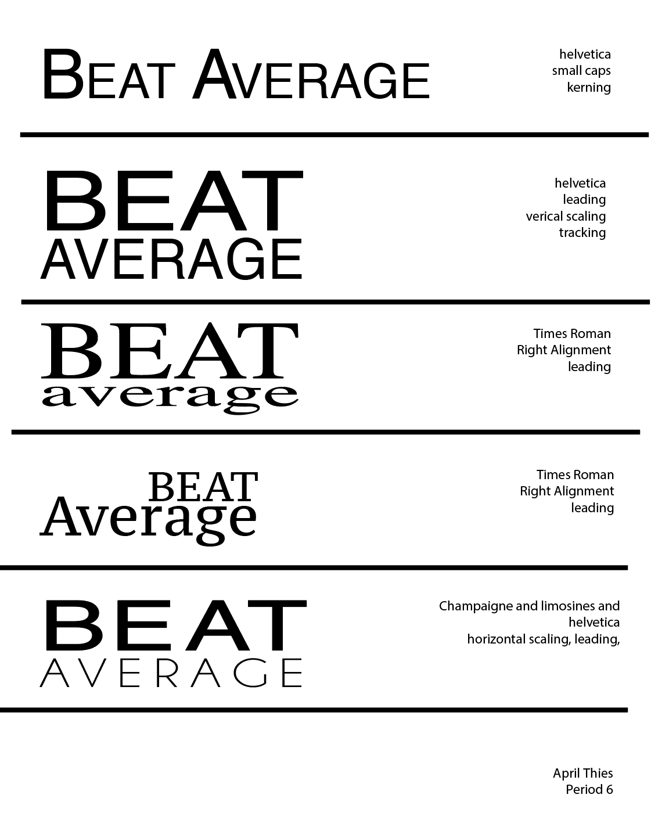
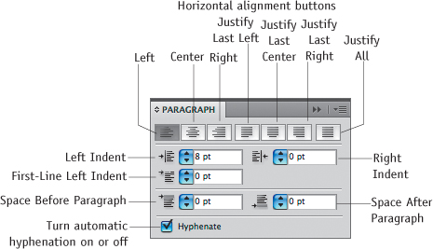
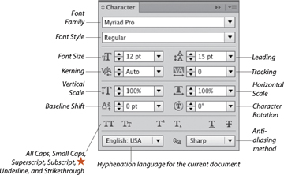
Example:

