LOGO CREATING—Illustrator— First sketch out your idea! Turn sketch in with your Designs--

Assignment 1: 50 points

Class assignment—We will vote on one of the company’s below to create a design for. Everyone will create a design for this Company—Must have at least 3 designs.

Part 1: Brain storm and rough draft sheet (10 pts), think color, font, etc. Limit

yourself to no more than 3 colors (we will decide this one as a group) Make swatches of these colors and

Part 2: Scan your image or take picture and put into illustrator. Make 2 variations…Make 4 color variations of each (1 must be black and white).

Assignment 2: 70 points

You will go to https://www.designcrowd.com/ and look at logo design jobs. Find a job you are interested in and print out the information and get to work on it. Brainstorm and rough draft an entire page, look at different fonts and get your color scheme set. You will need to do at least 2 different mockups
Brain Touch
Brain Touch offers a wide range of computer services - hardware, software, as well as the import and export of electronic technology. They were seeking a simple, professional, technology-orientated logo which could be used for both online and print.

The Big Chill Creamery
The Bill Chill Creamery is a unique ice-cream shop located in Delaware. It has a classic laid back beach feel inside and out. They sell 30 flavors of Hershey’s ice-cream, 4 flavors of homemade ice-cream, freshly baked desserts, coffee, candy and snacks. They were seeking a creative, upbeat, timeless logo and completely open to the colors used.

Smiley Energy
Smiley Energy, they invent and produce various gadgets with the common purpose of improving the environmental impact of everyday tasks. e.g. reducing the use of electricity and water by measuring the household-consumption and generating playful stats/competitions through the Smiley Energy website.
The word energy should be perceived as green/environmentally friendly energy, so please avoid using symbols with negative connotations such as lightning bolts or atomic symbol.

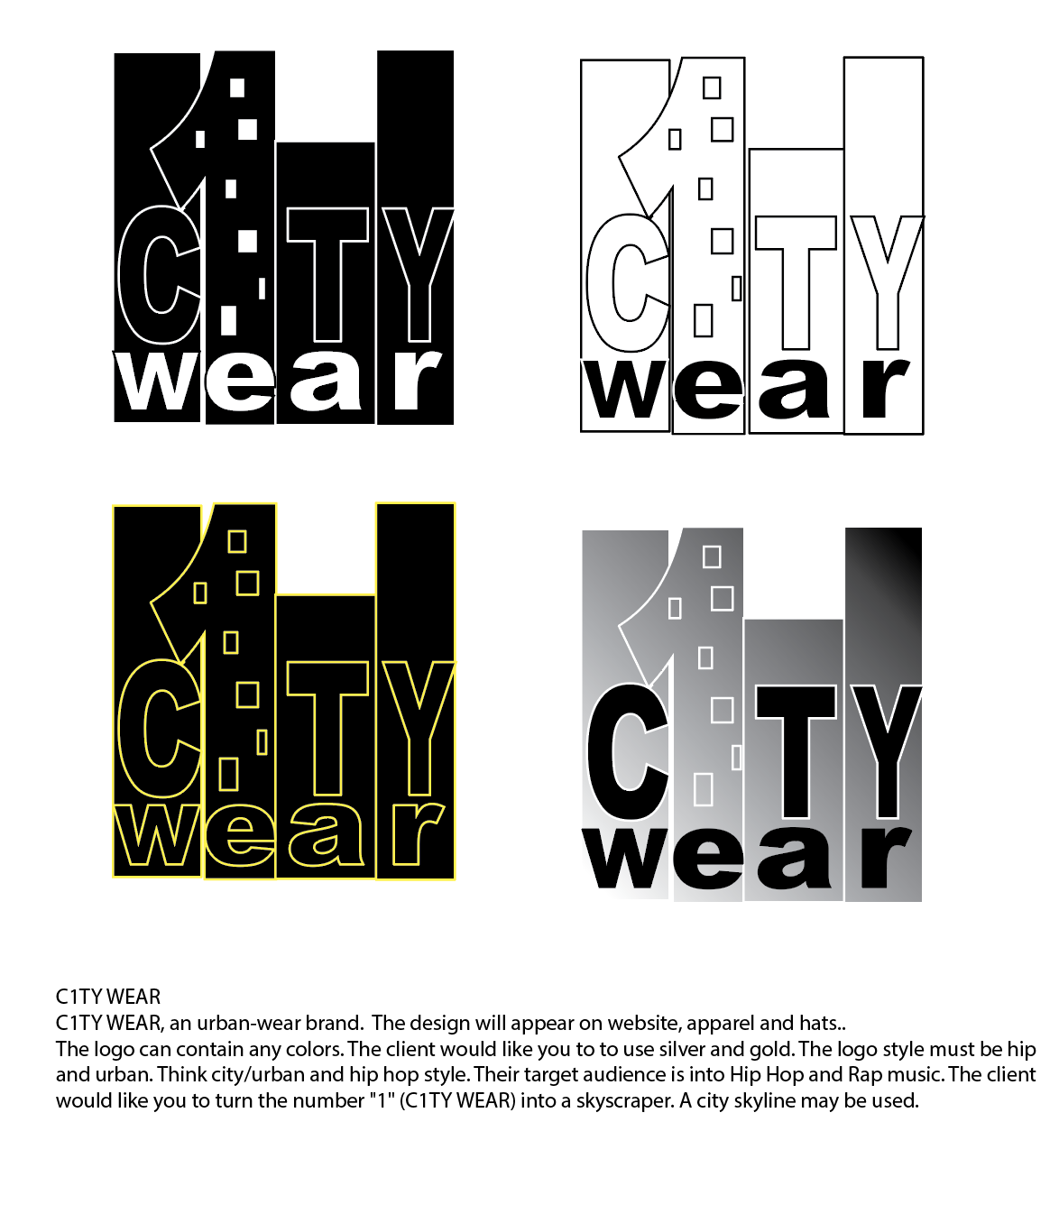

C1TY WEAR
C1TY WEAR, an urban-wear brand. The design will appear on website, apparel and hats..
The logo can contain any colors. The client would like you to to use silver and gold. The logo style must be hip and urban. Think city/urban and hip hop style. Their target audience is into Hip Hop and Rap music. The client would like you to turn the number "1" (C1TY WEAR) into a skyscraper. A city skyline may be used.

10 Simple Tips For Creating a Logo
- Do NOT use clip art. This is probably the one worst thing you can do when designing a logo. Your logo needs to be unique. Using clip art not only shows that you couldn’t afford a designer but also makes your website look unprofessional.
- Before even starting the design, just start sketching. This is the biggest and probably most important step that many designers tend to miss. Your logo needs to tell a story – To do this, think of what you want your users to think the moment they see it. Start sketching and only when you’re happy with a pencil design do you have to start designing in Illustrator or Photoshop.
- If possible, design your logo in Vector format – I have used Photoshop so many times in the past and then realized that I couldn’t make my logo bigger without losing quality. If you design logos often, learn Illustrator.
- Keep your logos simple. When sketching I usual just start with the name of the website and see what forms I can get out of it. The more complex a logo is, the harder it will be for your users to remember it. Don’t confuse ‘complex’ with ‘striking’ though. Your logo can still be striking and simple by playing around with colors and positioning.
- If possible, design a logo that will look good on a light and dark background. You never know where you’ll be using the logo in the future. If you later find out it’s ugly on black, it might be too late to change.
- Avoid ordinary fonts that every designer can recognize. If possible, use a premium font or create your own. If you are going to use a standard font, make sure it has something unique in the design to make it stand out, or edit some of the features in Illustrator to make it unique.
- If you’re out of ideas, have a look at some examples online. Search for “top logos list” on Google and start browsing examples. You’re bound to come across something you like. Don’t copy – Use the ideas you like from multiple logos to create your own unique design.
- Try create a logo with good contrast – Make it as easy for users to see as possible. Try mess around with different color schemes – You’d be surprised what a huge difference color can make.
- Don’t be afraid to experiment – Some of the best logos are those that are completely unique because of their weird design. Try sketching different shapes that are related to your website/company and see if any one of them would work as a logo.
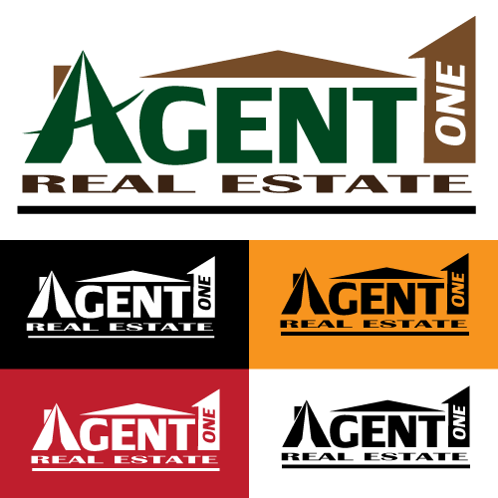
- Finally, do NOT expect to create a logo in one hour. In fact, after creating your first mock-up, stop working on it and have a look at it the next day. You’ll be surprised what a night’s sleep can do to your perception of your design.
EXAMPLES
